**Biology STAAR Review Stations**

**Day 5**

**Category # 2 Mechanisms of Genetics (6.E, 6.F, 6.G, 6.H)**

6.E identify and illustrate changes in DNA and evaluate the significance of these changes

6.F predict possible outcomes of various genetic combinations such as monohybrid crosses, dihybrid crosses and non-Mendelian inheritance

6.G recognize the significance of meiosis to sexual reproduction

6.H describe how techniques such as DNA fingerprinting, genetic modifications, and chromosomal analysis are used to study the genomes of organisms

**6.E, 6.F, 6.G, 6.H Pre-Test Score__________ Focus TEKS__________**

|  |  |  |  |  |
| --- | --- | --- | --- | --- |
|  | **6.E** | **6.F** | **6.G** | **6.H** |
| **Interactive Quizzes** | **DNA and Genes**  <http://www.glencoe.com/qe/science.php?qi=2502> | **Mendelian Genetics**  <http://glencoe.mheducation.com/sites/0078802849/student_view0/unit3/chapter10/section2/self-check_quizzes-english.html> | **Meiosis**  <http://glencoe.mheducation.com/sites/0078802849/student_view0/unit3/chapter10/section1/self-check_quizzes-english.html> | **DNA Fingerprinting Quiz**  <http://www.quia.com/quiz/447670.html?AP_rand=1093351065> |
| **Graphic Organizers** | **Mutation Graphic Organizer**  See handout | **Dihybrid Cross Practice Punnet**  **Square**  **Activity**  See handout | **Meiosis Graphic Organizer**  See handout | **Genetic Variation Graphic Organizer**  See handout |
| **Virtual Labs** | **Damage to DNA Leads to Mutation Simulation**  <http://www.hhmi.org/biointeractive/damage-dna-leads-mutation>  **Addition and Deletion Mutations Simulation**  <http://glencoe.mcgraw-hill.com/olcweb/cgi/pluginpop.cgi?it=swf::550::400::/sites/dl/free/0078802849/592990/Addition_and_deletion_mutations.swf::Addition%20and%20Deletion%20Mutations> | **Dihybrid Cross Simulation**  <http://www.dnaftb.org/5/problem.html>  **Completion_____**  **Punnet Squares Virtual Lab**  <http://glencoe.mcgraw-hill.com/sites/dl/free/0078802849/383934/BL_05.html> | **Meiosis Internet Activity**  <http://www.lpscience.fatcow.com/jwanamaker/animations/meiosis.html> | **Create a DNA Fingerprint Virtual Lab**  [**http://www.pbs.org/wgbh/nova/education/body/create-dna-fingerprint.html**](http://www.pbs.org/wgbh/nova/education/body/create-dna-fingerprint.html) |
| **Vocabulary** | **DNA Flashcards**  http://quizlet.com/20610090/unit-5-dna-vocabulary-list-flash-cards/ | **Mendelian Genetics**  **Flashcards**  <http://quizlet.com/1471356/mendelian-genetics-vocabulary-terms-flash-cards/> | **Meiosis Flashcards**  <http://quizlet.com/8869794/meiosis-vocabulary-terms-flash-cards/> | **DNA Fingerprinting Flashcards**  [**http://quizlet.com/1823048/dna-fingerprinting-flash-cards/**](http://quizlet.com/1823048/dna-fingerprinting-flash-cards/) |
| **Video Clips** | **Mutations: The Potential Power of a Small Change**  [www.youtube.com/watch?v=GieZ3pk9YVo](http://www.youtube.com/watch?v=GieZ3pk9YVo) | **Mendelian Genetics**  <https://www.youtube.com/watch?v=oVl8OH_7QSc> | **Meiosis the Great Divide**  <https://www.youtube.com/watch?v=toWK0fIyFlY> | **DNA Fingerprinting**  [**https://www.youtube.com/watch?v=DbR9xMXuK7c**](https://www.youtube.com/watch?v=DbR9xMXuK7c) |

**Critical Thinking Questions**

1. How do changes in DNA affect the resulting protein?

2. What are the implications of these changes?

3. How does mitosis compare to meiosis?

4. How can genetic disorder be detected using different techniques?

5. How do the results of dihybrid crosses express themselves in living organisms?

6. Describe ways to study the genomes of organisms

**6.E Mutations Graphic Organizer**

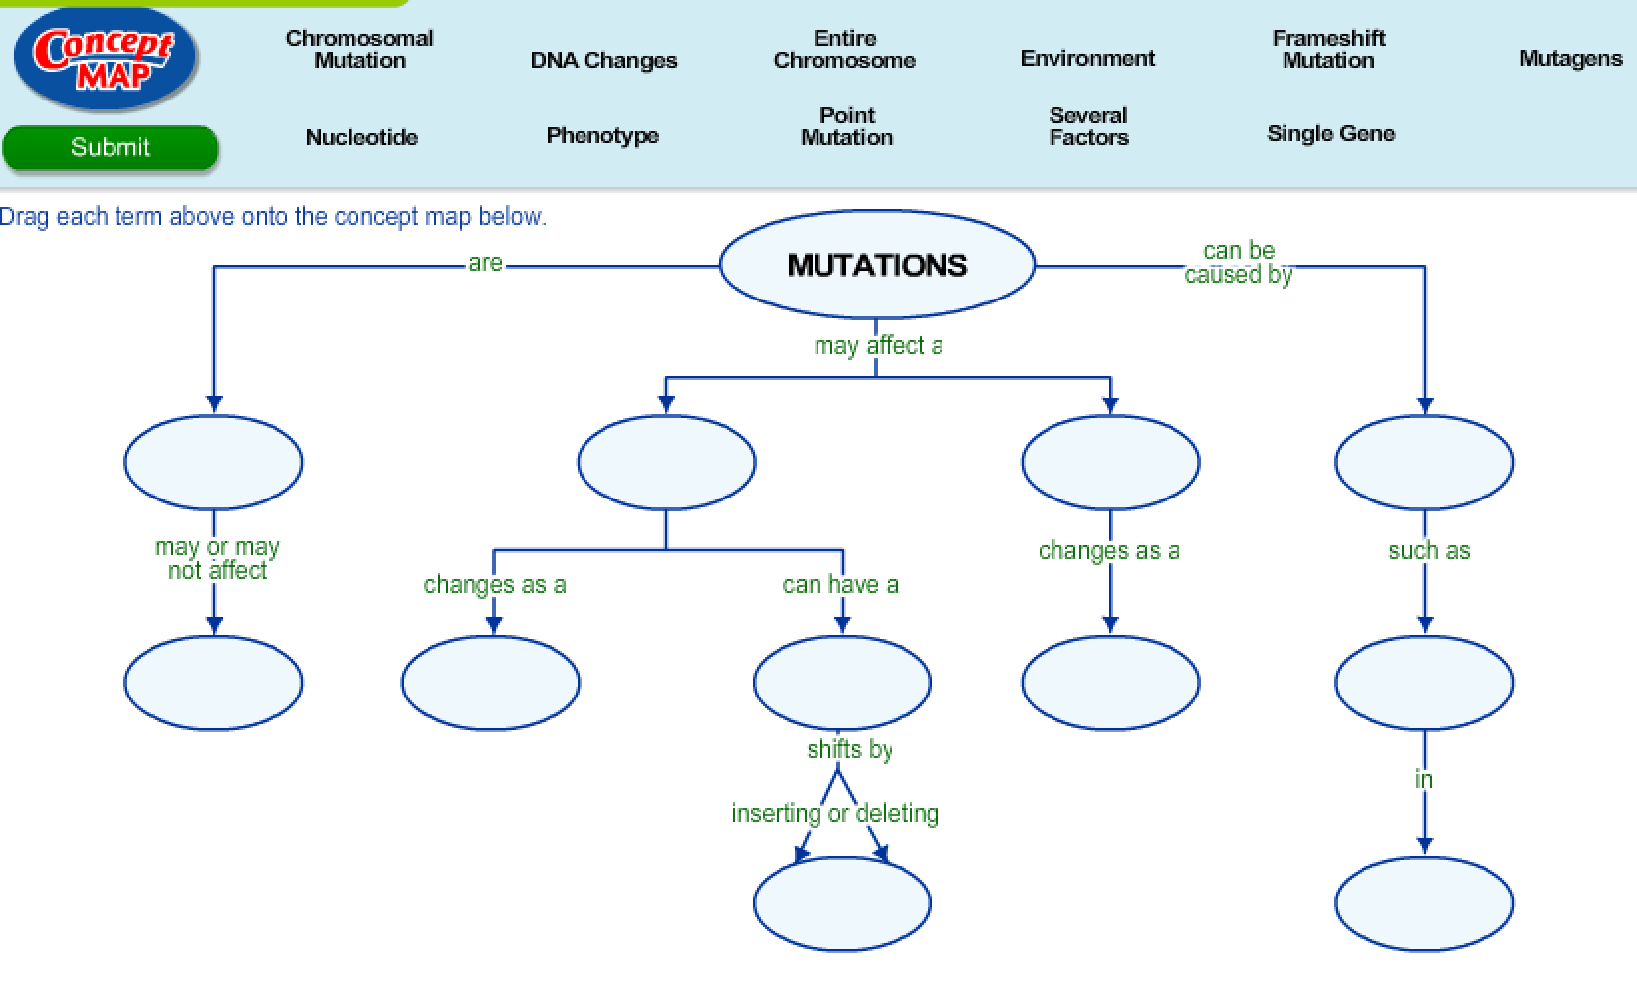

**6.F Dihybrid Cross Practice Punnet Square**

[**http://www.biologycorner.com/worksheets/genetics_2traits_bio2.html#.UzWthq1dWMU**](http://www.biologycorner.com/worksheets/genetics_2traits_bio2.html#.UzWthq1dWMU)

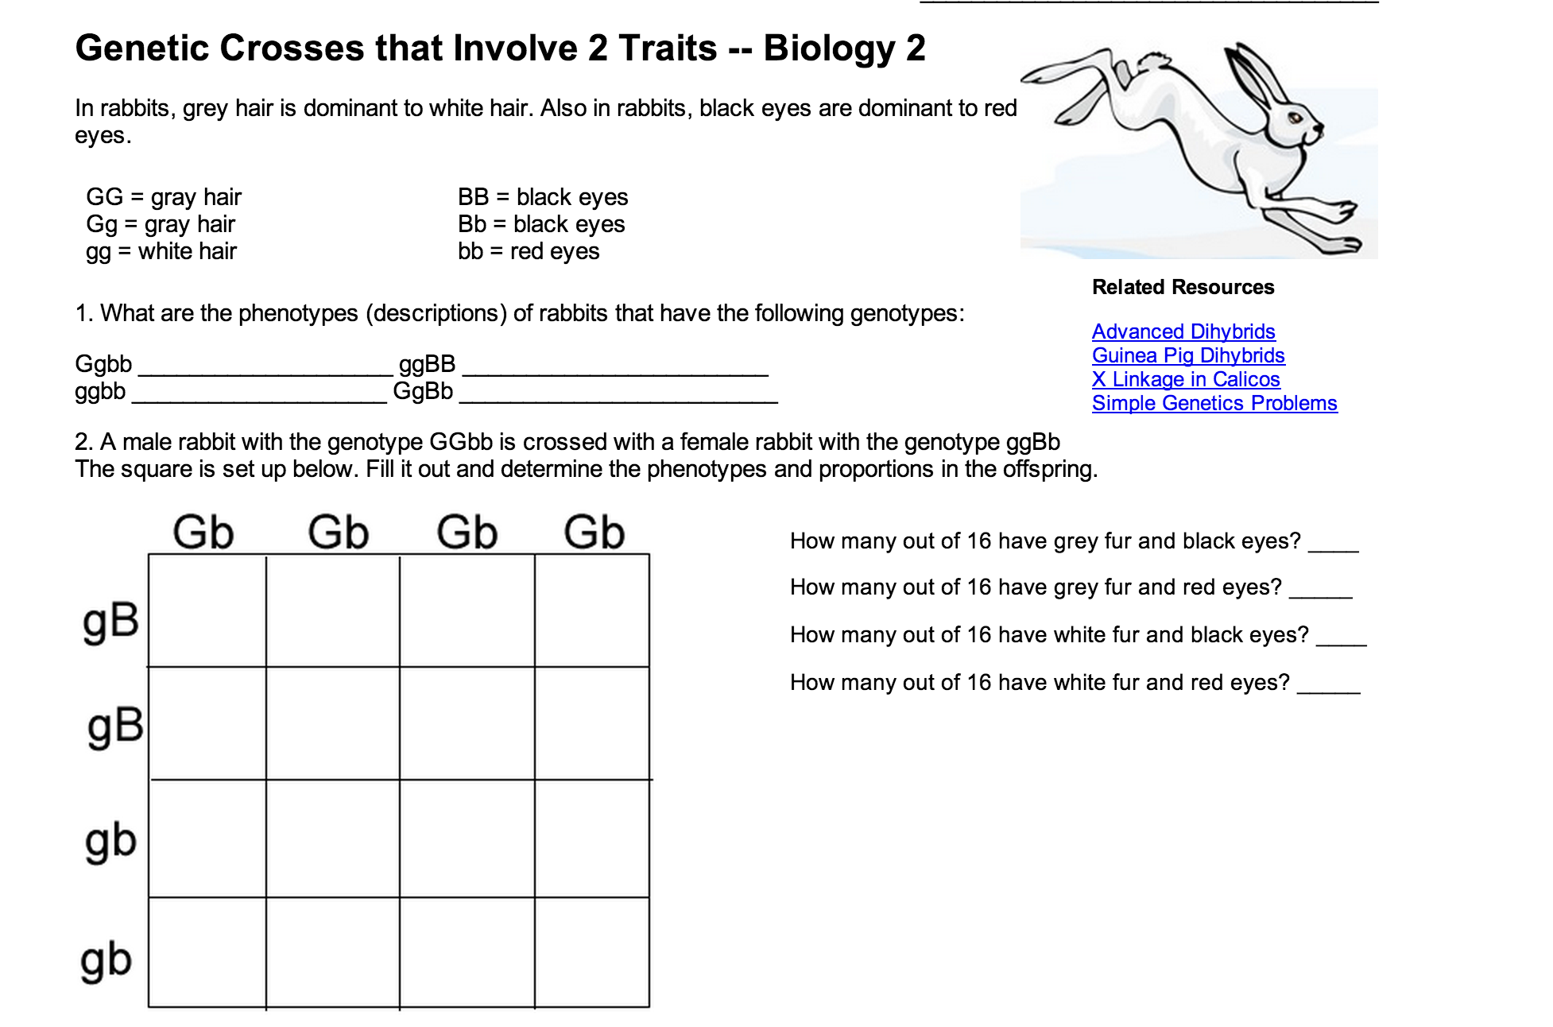

**6.G Meiosis Graphic Organizer**

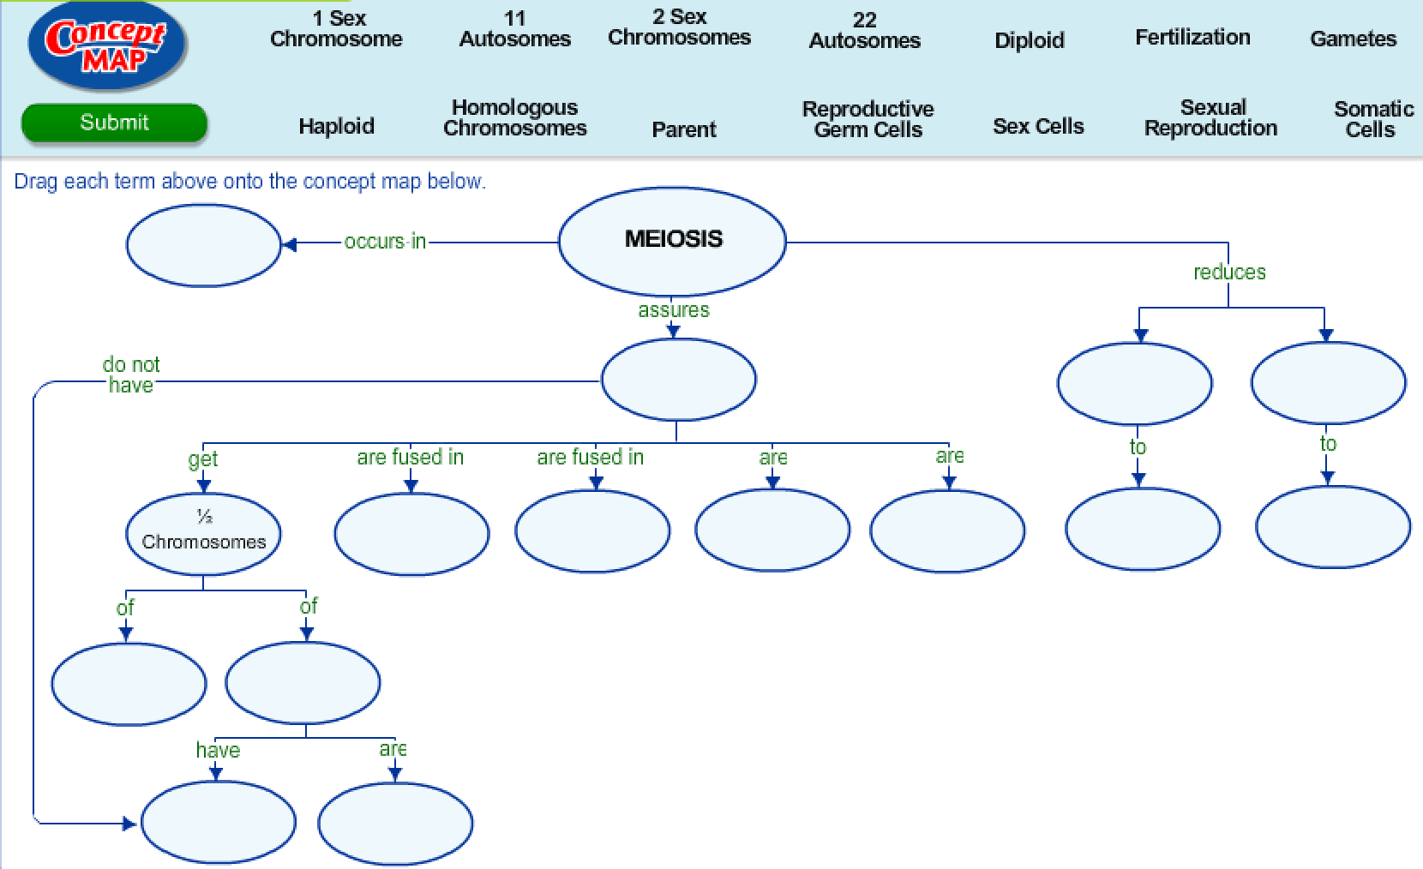

**6.H Genetic Variation Graphic Organizer**

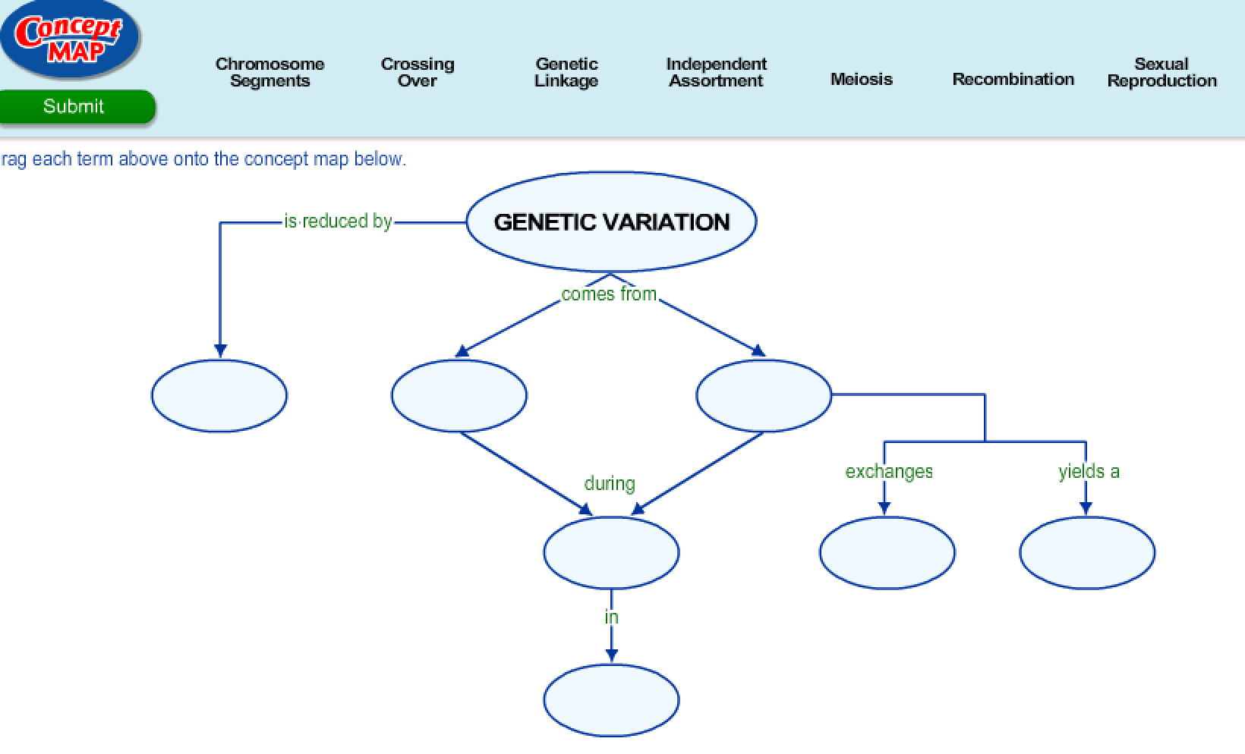

**Day 5 Review Questions**

**6.E**

http://glencoe.mheducation.com/olcweb/styles/shared/spacer.gifhttp://glencoe.mheducation.com/olcweb/styles/shared/spacer.gif  
_____1. This shows a genetic process resulting in ____.

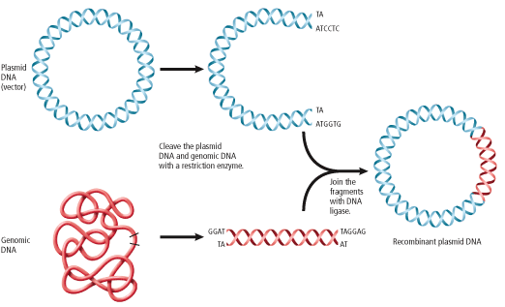

1. DNA ligase
2. Recombinant DNA
3. Plasmids
4. Restriction enzymes

**6.E**

_____2. What DNA tool has been applied to the DNA sequence in this figure?

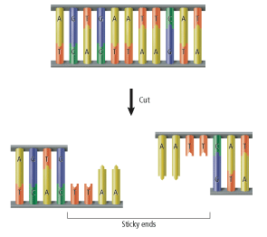

a. restriction enzymes

b. gel electrophoresis

c. transgenic organisms

d. proteins

6.E

_____3. Which of the following statements is true about mutations?

1. most mutations are fatal to organisms
2. most mutations have no effect on an organism
3. most mutations are helpful to an organism
4. most mutations are harmful to organisms

6.E

_____4. One strand of DNA with the sequence AAC AAG CCC undergoes a mutation and is changed to CAC AAG CCC. How will this mutation affect the amino acid sequence?

1. the amino acids will remain the same
2. one amino acid will change
3. two amino acids will change
4. all of the amino acids will change

6.F

_____5. If an individual possesses two recessive alleles for the same trait, the individual is said to be

a. homozygous for the trait.

b. haploid for the trait

c. heterozygous for the trait.

d. mutated.

6.F

_____6. **Hitchhiker’s thumb** (H) is **dominant** to **no hitchhiker’s thumb** (h). A woman who does **not have hitchhiker’s** **thumb** marries a man who is **heterozygous** for hitchhiker’s thumb. What is the **probable genotypic ratio** of their children? h h

|  |  |
| --- | --- |
| Hh | Hh |
| hh | hh |

a. 0% Hh : 100% hh

b. 50% Hh : 50% hh H

c. 75% Hh : 25% hh

d. 100% Hh : 0% hh h

6.F

_____7. Bill grows two varieties of corn in his garden. One variety produces large ears of corn and one makes small ears of corn. When Bill crosses the **two plants** the **resulting** ears of corn are **medium in size**. Which statement ***best*** explains **Bill’s result**?

a. The corn underwent a spontaneous mutation.

b. Ear size is a trait that shows incomplete dominance.

c. Ear size is controlled by the environment.

d. Ear size is not genetically controlled.

6.F

_____8. John has **one recessive allele** for blue eyes **(b) and one dominant allele** for brown eyes **(B).** Amy also has **one recessive allele** for blue eyes and **one dominant allele** for brown eyes. What **phenotype** is an **offspring** of John and Amy **most likely** to express?

a. Bb

b. BB

c. blue eyes

d. brown eyes

6.G

_____9. Crossing-over occurs

a. during prophase

b. during fertilization

c. during prophase one

d. at the centromere

6.G

_____10. DNA replication takes place ____ during meiosis.

**A)**http://glencoe.mheducation.com/olcweb/styles/shared/spacer.gifoncehttp://glencoe.mheducation.com/olcweb/styles/shared/spacer.gif

**B)**http://glencoe.mheducation.com/olcweb/styles/shared/spacer.giftwice

**C)**http://glencoe.mheducation.com/olcweb/styles/shared/spacer.giffour timeshttp://glencoe.mheducation.com/olcweb/styles/shared/spacer.gif

**D)**http://glencoe.mheducation.com/olcweb/styles/shared/spacer.gifsix times

6.G  
_____11. Homologous chromosomes separate during which phase(s) of meiosis?

1. interphase
2. anaphase I
3. telophase I
4. interphase and telophase I

[**[http://glencoe.mheducation.com/olcweb/styles/shared/spacer.gif](http://glencoe.mheducation.com/sites/0078802849/student_view0/unit3/chapter10/section1/self-check_quizzes-english.html#quest4)**](http://glencoe.mheducation.com/sites/0078802849/student_view0/unit3/chapter10/section1/self-check_quizzes-english.html#quest4)

6.G  
_____12. Which of the following is not true of meiosis?

a. involves DNA replication

b. provides genetic variationhttp://glencoe.mheducation.com/olcweb/styles/shared/spacer.gif

c. occurs in reproductive cells

d. prevents genetic variation

6.H

_____13. A mutation caused by a piece of DNA breaking away from its chromosome and becoming attached to a nonhomologous chromosome is called:

a.deletion

b.duplication

c.inversion

d.translocation

6.H

_____14. Genetic engineering refers to the process of

a. creating new DNA molecules from nucleotide sequences.

b. rearranging nucleotides in a gene of an organism so that new traits appear in the

development of an embryo.

c. moving genes from a chromosome of one organism to a chromosome of a

different organism.

d. building a new species by combining genes of different organisms.

6.H

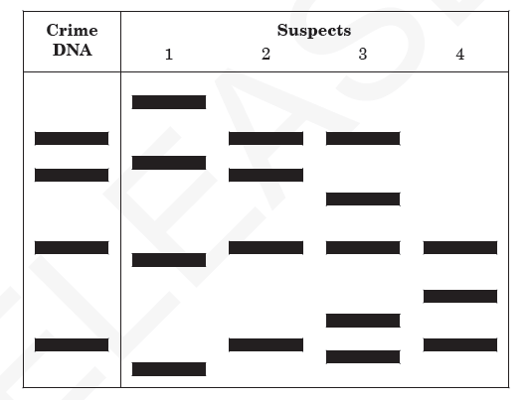_____15. This diagram represents samples of **DNA** that were cut with a restriction enzyme during DNA **fingerprinting** in a crime lab.

Which **technique** was used to produce these bands?

a. cloning

b. gel electrophoresis

c. gene splicing

d. genetic engineering

6.H

http://glencoe.mheducation.com/olcweb/styles/shared/spacer.gifhttp://glencoe.mheducation.com/olcweb/styles/shared/spacer.gif  
_____16. How are DNA fragments separated in DNA fingerprinting?

A)http://glencoe.mheducation.com/olcweb/styles/shared/spacer.gifcomputer analysishttp://glencoe.mheducation.com/olcweb/styles/shared/spacer.gif

B)http://glencoe.mheducation.com/olcweb/styles/shared/spacer.gifgel electrophoresishttp://glencoe.mheducation.com/olcweb/styles/shared/spacer.gif

C)http://glencoe.mheducation.com/olcweb/styles/shared/spacer.gifbioinformaticshttp://glencoe.mheducation.com/olcweb/styles/shared/spacer.gif

D)http://glencoe.mheducation.com/olcweb/styles/shared/spacer.gifDNA microarrays

**Day Five Review Questions (6.E, 6.F, 6.G, 6.H)**

**Answer Sheet**

**_____1.**

**_____2.**

**_____3.**

**_____4.**

**6.E Score__________/4**

**_____5.**

**_____6.**

**_____7.**

**_____8.**

**6.F Score__________/4**

**_____9.**

**_____10.**

**­­­­­_____11.**

**_____12.**

**6.G Score__________/4**

**_____13.**

**_____14.**

**_____15.**

**_____16.**

**6.H Score__________/4**

**Day Five Review Questions (6.E, 6.F, 6.G, 6.H)**

**Key**

**__B__1.**

**__A__2.**

**__B__3.**

**__B__4.**

**__A__5.**

**__B__6.**

**__B__7.**

**__D__8.**

**__C__9.**

**__A__10.**

**__B__11.**

**__D__12.**

**__D__13.**

**__B__14.**

**__B__15.**

**__B__16.**